An Explainable AI Framework for Loan Risk Assessment and Decision Support System using Machine Learning

Abhishek Yadav
CSE - AIML
ABES Engineering College
Ghaziabad, India

Ansh Goel
CSE - AIML
ABES Engineering College
Ghaziabad, India

Ayush Saini
CSE - AIML
ABES Engineering College
Ghaziabad, India

Ms. Mansi Aggarwal
CSE - AIML
ABES Engineering College
Ghaziabad, India

abhishek.24b1531113@abes.ac.in ansh.24b1531002@abes.ac.in ayush.24b15310198@abes.ac.in mansi.aggarwal@abes.ac.in

Abstract—The rising trend of digitizing the banking industry led to a necessity for effective and clear methods of approving loans. The paper describes an Explainable AI framework used for risk assessment and loan application decision-making based on machine learning. The dataset that is used for loan application approval included 20,000 applications and 36 features, and was processed to fill missing values, encode categorical variables, conduct exploratory data analysis, and do feature engineering. As the first step, the nine machine learning classifiers were tested, and the ones being considered in the paper were Logistic Regression, Naive Bayes, Support Vector Machine, and CatBoost. CatBoost was finally chosen as the prediction model and it went through the five-fold cross-validation process.CatBoost achieved 100% accuracy, precision, recall, and F1-score on the independent test set and was selected as the final prediction model. Five-fold cross-validation further yielded a mean accuracy of 99.9625% and a mean F1-score of 99.9209%, with an F1-score standard deviation of 0.0497%. SHAP and LIME were used to show the explanations of the global and local loan application prediction results and make a comparison of how different characteristics of approved and rejected applicants were useful. The final model is presented in a Streamlit application that is able to make loan predictions, perform risk assessment, provide explanations for the final decision taken and offer recommendation-based decision support. Index Terms—Machine Learning, Loan Approval, CatBoost, Explainable AI, SHAP, LIME, Risk Assessment, Decision Sup-
port.
- Introduction
Due to rapid digitization in the banking and financial spheres, the demand for sophisticated systems that would enable precise and efficient evaluation of loan applications has grown. Today, financial organizations get thousands of applications which must undergo assessment regarding many criteria such as income, employment listing, credit history, amount of loan, debt-to-income ratio, and repayment ability. Traditional manual assessment and statistical methods are often time-consuming and may not be accurate in discovering relationships between the mentioned factors. Thus, machine
learning-based automated loan approval systems have become crucial tools for effective decision-making.
The machine learning algorithms are capable of under-standing historical data related to loans and applying it to determine whether the applicant is reliable or not. Logistic regression and tree algorithms, random forests, support vector machines, and boosting methods can enhance the process of loan evaluation. However, it is important to note that many effective ML models work as black boxes, bringing predictions without clearly defining the reasons for each separate decision. In finance, where loan decisions influence borrowers’ fate, it is vital for the ML application to make the information open and accountable.
XAI attempts to over come the limitations of the lack of clear explanations as to how predictions using machine-learning algorithms were made. SHAP provides feature-level contributions, and thus works for explaining predictions of machine-learning models on both global and local levels. On the other hand, LIME provides explanations for individual predictions through local approximation of the target model with an interpretable one. While both methods were widely used for explaining machine-learning prediction outcomes, their efficiency and comparability in the field of lending is still not sufficiently researched. Moreover, nowadays the existing methods are mostly focused on prediction process and expla-nations with little consideration of applicant risk assessment along with decision support based on recommendations.
In view of this, the current study aims to develop “An Explainable AI Framework for Loan Risk Assessment and Decision Support Using Machine Learning.” The main aim of the framework is to perform an assessment of the most widely used machine learning algorithms which can be applied for loan approval prediction. In addition, the framework will apply SHAP and LIME methods to provide explanations for every decision made. Finally, the system will integrate applicant risk assessment and recommendation-based deci-sion making within the streamlit-application.The proposed

framework therefore aims to combine predictive performance, interpretability, risk assessment, and practical decision support into a unified loan approval system.
- Literature Review
An overview of earlier research on Loan approval prediction is provided in this section. The basis for subsequent explo-rations in the field has been established by this study.
Historically, credit-risk evaluation has depended on sta-tistical methods; particularly because of their simple nature and interpretation. However, in recent times, researchers have been using machine learning methods in order to obtain non-linear relationship and complex shapes in economic data. The research by Dastile et al. [11] provided a systematic review of statistical and machine learning models for credit scoring with a growing tendency towards the use of ensemble classifiers. The research by Carta et al. [12] proved the effi-ciency of using ensemble methods in credit scoring while the research by Zhang and Yu [13] represented a recent overview of classification algorithms, data features, machine learning methods used, interpretability, and fairness in consumer credit-risk evaluation.
Nowadays, the research studies investigate the applications of machine learning in loan approval. Faiaz et al. [1] cre-ated a loan predicting model that is characterized by high transparency as it uses CatBoost and SHAP, comparing the performance of CatBoost with other machine learning models. Li and Li [2] developed a complete pipeline for loan pre-dicting involving feature selection, machine learning, SHAP interpretation, and deployment of the solution. Thus it can be concluded that these research studies assist in understanding the potential of modern machine learning approaches for automated loan Approval System.
Nonetheless, predictive accuracy alone is not enough for financial decision-making, as complex models fail to articulate the reasoning behind certain predictions. Ariza-Garzo´n et al.
[3] proposed the application of SHAP in explaining machine learning-based credit scores, while Dastile and Celik [4] examined the importance of explainability in credit scoring with deep machine learning algorithms. To add, Bussmann et al. [7] and de Lange et al. [8] highlighted the significance of explainability in credit risk management, emphasizing its use-fulness for banks. Babaei et al. [9] studied how Shapley-based methods can be used to achieve explainability in FinTech lending. Different techniques of XAI were compared regarding financial applications as well. Gramegna and Giudici [10] focused on evaluating SHAP and LIME in the context of credit risk analysis, thus making it relevant for the present research. Counterfactual explanatory approaches were then studied in order to devise actionable rationale behind individual crediting decisions [5], [6].
However, in spite of many accomplishments, most of the research is limited to either predictions quality or model inter-pretability. The present study aims to overcome this limitation by combining features of multi-model loan approval predic-tion, features engineering, CatBoost modelling, comparison of
SHAP and LIME, assessment of applicants’ risks, decision support, and Streamlit deployment.
- Methodology
The framework introduced here is developed to provide predictions regarding loan approval utilizing machine learning, together with the use of the explainable artificial intelligence to explain the individual decisions. The approach consists of obtaining the dataset, checking and cleaning the data, doing exploratory data analysis, performing the encoding of categor-ical variables, doing correlation analysis, performing train-test split, feature scaling, developing the machine learning model, conducting feature engineering, evaluating different models, selecting the final model, and using specific techniques like SHAP and LIME to explain the decision-making process. The entire experiment was conducted in Python using Kaggle notebooks, while the final model and preprocessing pipeline were integrated into a Streamlit-based application for interac-tive loan prediction, risk assessment, explanation, and decision support.
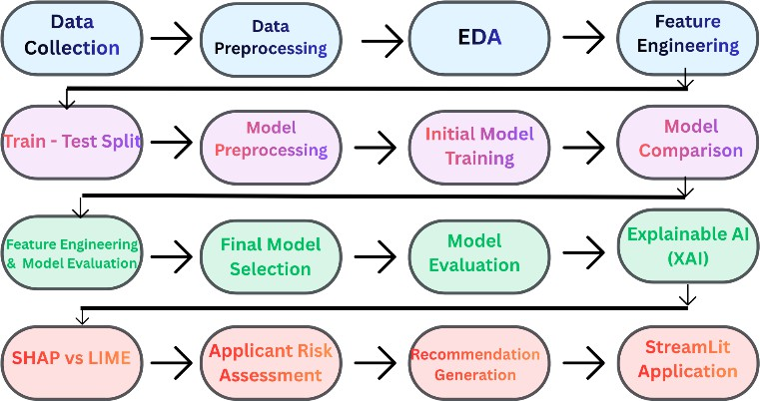
Fig. 1. Methodology Flow

- Dataset Description and Preprocessing
The original dataset contains 20,000 loan applications and
36 features. After preprocessing, categorical encoding, and feature engineering, the resulting feature matrix was used for model training. It consists of information about demographics, employment, finances, credit history, loan application and risk. The target variable is LoanApproved with 0 being rejected and 1 approved applications. In total, there are 15,220 rejected and 4,780 approved applications, pointing to a high level of imbalance in the target variable. The inputs to the models include attributes describing applicants such as age, income per year, employment status, level of education, marital status, experience, and number of dependents while financial vari-ables include loan covered, monthly debt payments, saving account balance, checking account balance, assets, liabilities, monthly income, net worth, and monthly payment. Credit-related variables include credit score, credit card utilization, number of credits opened, number of investigation, debt-to-income ratio, bankruptcy history, previous default on loans as well as overall payment history and the length of the credit

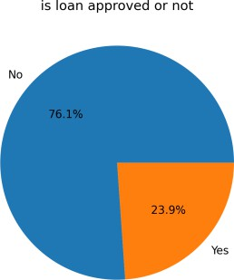

Fig. 2. Loan approval distribution pie chart

history. Initially, the dataset is loaded into a Pandas Dataframe,
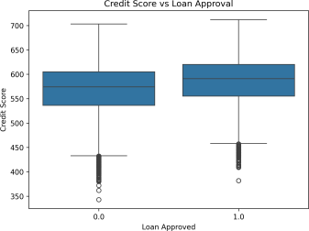

Fig. 3. Credit Score vs. Loan Approval boxplot

which is then utilized for its preliminary analysis using methods comprising dataset preview, structural information, descriptive statistics, and missing-value analysis. Numerical and categorical variables are separated utilizing the data type of the variable. The missing numerical data is treated using mean imputation, while the categorical data is treated using the mode of the variable so that machine learning algorithms work with complete data. Before going on to training of the model, the ApplicationDate feature is removed from the dataset as it is a date field and does not serve as a direct feature in the modeling pipeline. The other categorical features include variables such as employment status, education level, loan pur-pose, home ownership status, and marital status. Exploratory
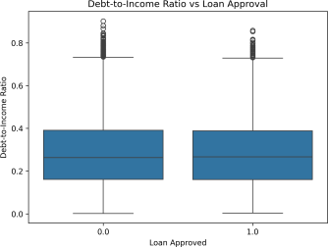

Fig. 4. Debt-to-Income Ratio vs. Loan Approval boxplot

Data Analysis is conducted in order to gain insights into the distribution of the target variable and relevant features of the applicants. Histograms are utilized to analyze the distribution of annual income and credit scores making use of box plots
for the yearly income vs debt-to-income ratio, credit score and risk score vs loan approval ratio analysis. A correlation matrix is produced in order to get a better idea of the correlation between the numerical features and the target variable.
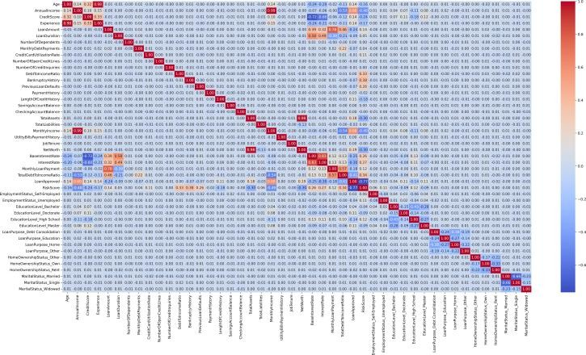
Fig. 5. Correlation HeatMap

- Feature Engineering and ML Model Development
Upon finishing the preprocessing and exploratory analysis of the data, we separate the data into features X and target variable y. The train-test split is done using the 80:20 ratio with a specified shuffle state of 42. We fit the StandardScaler on the training data to ensure that no information seeped into the scaling process.
At this point, we will run nine different classification algo-rithms for a comprehensive performance evaluation: Logistic Regression, K-Nearest Neighbors, Gaussian Naive Bayes, De-cision Tree, Random Forest, Support Vector Machine, Gradient Boosting, XGBoost, and CatBoost. All models will use the same training data and will be evaluated on the test data using performance metrics such as accuracy, precision, recall, F1-score, and confusion matrix.
Based on the initial evaluation, Logistic Regression, Naive Bayes, SVM, and CatBoost were further evaluated after feature engineering. CatBoost was selected as the final model based on its predictive performance and was additionally evaluated using stratified five-fold cross-validation.
Now, we will implement the feature engineering technique on the two key numeric features. In this phase, we compute the square of the DebtToIncomeRatio and CreditScore feature so the model can capture non-linear relations:
After the transformation, both the DebtToIncomeRatio and CreditScore original attributes will be dropped from the feature matrix. The transformed dataset will be split into train-test sets and standardized again. Finally, we will train the following algorithms on the newly created dataset.
- Explainable Artificial Intelligence
In order to overcome the obscurity surrounding machine learning predictions, there was a professional incorporation of both SHapley Additive exPlanations and of Local Interpretable Model-Agnostic Explanations.

SHAP was employed to provide both local and global inter-pretation of the CatBoost model. The global SHAP summary as well as the feature-importance plots clearly identify the features that have the most significant impact on the model predictions. The waterfall plots clarify the role of each feature in a prediction for a particular application.
For local interpretability, SHAP waterfall plots were gener-ated for representative approved and rejected applicants.
LIME was additionally applied to the same representative applicants to identify local feature contributions.
The SHAP and LIME explanations were then compared using the common features identified by both methods. Direc-tional agreement was calculated to determine whether the two explanation techniques indicated similar positive or negative contributions for the selected applicants.
- Risk Assessment and Decision-Support System
The last CatBoost model along with all the relevant prepro-cessing parts was combined with a Streamlit application. The application receives information about an applicant through its user-friendly UI and processes it in the same way as the model. After processing, information is sent to the CatBoost model for obtaining loan status and approval/rejection probability.
There is also an assessment of risk in the model since it evaluates applicants and places them into specific categories depending on their probability of rejection from the model. Then the application introduces SHAP and LIME results in order to find out a reason for a particular prediction.
- Result And Discussion
- Model Performance
The performance of the proposed loan approval predic-tion framework was evaluated using nine machine learning classifiers: Logistic Regression, K-Nearest Neighbors (KNN), Naive Bayes, Decision Tree, Random Forest, Support Vector Machine (SVM), Gradient Boosting, XGBoost, and CatBoost. Precision, recall, F1-score, and accuracy were used to compare the predictive performance of the models. The perfect perfor-mance achieved by CatBoost, as shown in table II, indicates an accuracy, precision, recall, and F1 score value of 1.0000. In addition to CatBoost, the logistic regression also produced similar scores of 1.0000 in all four evaluated parameters, while the SVM classifier has produced the accuracy score of 0.9990

TABLE I
Performance Comparison of Machine Learning Models

Model Precision Recall F1 Accuracy
Logistic Regression 1.0000 1.0000 1.0000 1.0000
KNN | 0.9213 | 0.7365 | 0.8186 | 0.9170
Naive Bayes | 0.8767 | 0.9508 | 0.9123 | 0.9535
Decision Tree | 0.9880 | 0.9725 | 0.9802 | 0.9900
Random Forest | 0.9872 | 0.9823 | 0.9847 | 0.9923
SVM | 1.0000 | 0.9961 | 0.9980 | 0.9990
Gradient Boosting | 0.9980 | 0.9980 | 0.9980 | 0.9990
XGBoost | 0.9980 | 0.9990 | 0.9985 | 0.9993
CatBoost 1.0000 1.0000 1.0000 1.0000
and F1 score of 0.9980. As for the other classifiers, their accuracy results range from 0.9993 (for XGBoost) to 0.9990 (for Gradient Boosting). Random Forest and Decision Tree have attained the accuracy of 0.9923 and 0.9900 respectively. Due to its total predictive performance and compatibility with the proposed explainable framework, CatBoost was cho-sen as the final model for further analysis with the help of the
SHAP and LIME methods.
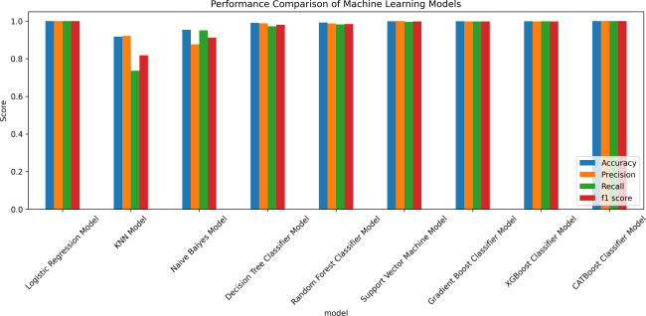

Fig. 6. Performance comparison of all implemented ML models

To further assess the stability of the selected CatBoost model, five-fold cross-validation was performed. The model achieved a mean accuracy of 99.9625%, mean precision of 99.8939%, mean recall of 99.9469%, and mean F1-score of 99.9209%. The F1-score standard deviation was 0.0497%, indi-cating consistent performance across the validation folds.
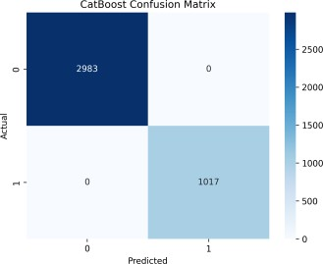

Fig. 7. Confusion Matrix for CatBoost

Based on the findings entered here, it can be concluded that the CatBoost was selected as the final model despite Logistic Regression also achieving perfect test-set performance.
- Explainability Results
In order to enhance the interpretability of the chosen CatBoost model, SHAP and LIME methods were used in predicting loans. SHAP thrives on its capability to extract both global relevance of features and localized explanations, thus pinpointing the crucial drivers of the prediction given by the model.
The contributions of various local SHAP factors in the decision of approval or rejection in individual cases were visualized using local SHAP waterfall plots. In addition to that, LIME method was applied to generate a local prediction

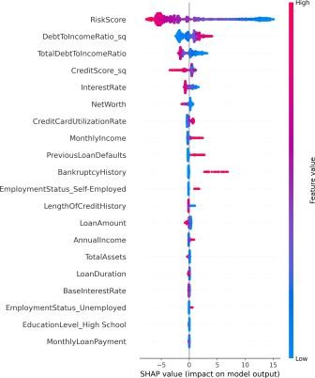

Fig. 8. SHAP Summary Plot
their values of feature contributions may vary due to dif-ferent method of explaining things. While SHAP gives a solid attribution method that supports both global and local interpretation, LIME aims at achieving a local approximation of the model for a particular prediction. Using SHAP and

TABLE II
SHAP and LIME Comparison

Feature | SHAP | LIME | Agreement
RiskScore | 10.4883 | 0.8227 | Yes
DebtToIncomeRatio sq | 2.1021 | 0.1010 | Yes
TotalDebtToIncomeRatio | 2.0913 | 0.0577 | Yes
MonthlyIncome | 0.3809 | 0.0186 | Yes
PreviousLoanDefaults  EmploymentStatus Self-Emplo | -0.1914  yed -0.1360 | -0.0801  -0.0506 | Yes  Yes

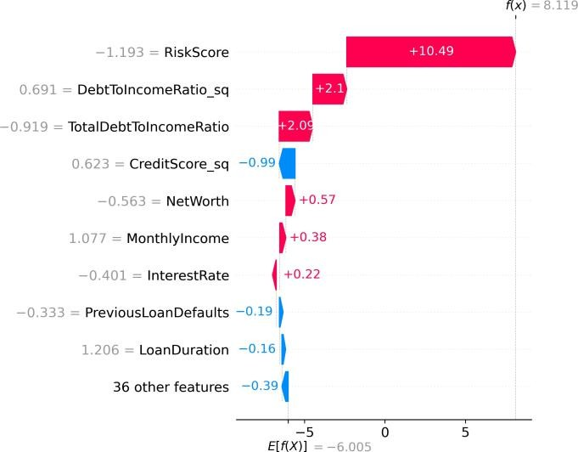

Fig. 9. SHAP Approved
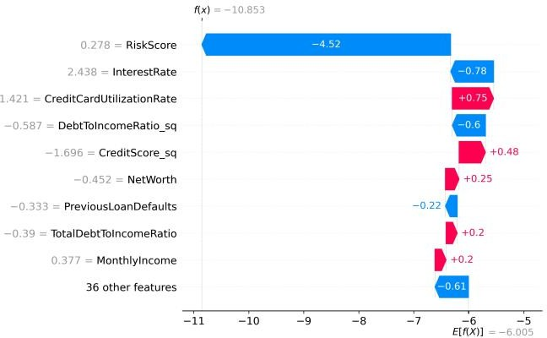

Fig. 10. SHAP Rejected

explanation based on the accounting of the features which helped the applicant in making a decision.
- SHAP and LIME Comparison
A comparison indicates that SHAP and LIME are both effective in terms of providing local explanations, though
LIME together increases the understanding of the proposed framework commendably because they are used to explain the model rather than just say whether the answer is approved or not.
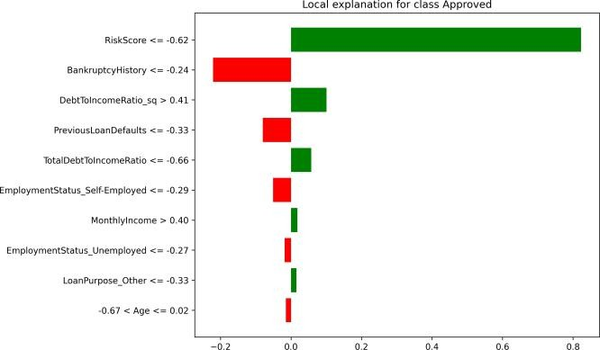

Fig. 11. LIME Approved

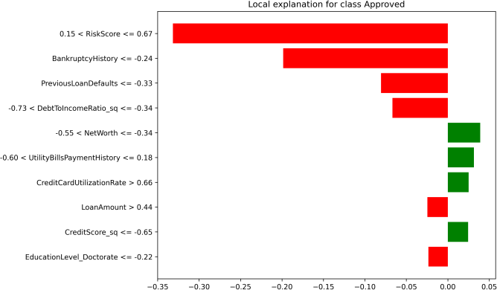

Fig. 12. LIME Rejected

- Streamlit Decision-Support Application
The last version of the CatBoost model and the models used in the preprocessing steps were brought to a Streamlit appli-cation that receives user information and returns the loan sta-tus prediction, approval/rejection prediction, risk assessment, SHAP and LIME authorizations, as well as recommendation.

The developed application demonstrates the real integration of machine learning and XAI in an interactive system for loan decision support that provides loan approval prediction, risk assessment, and explanations for the provided recommenda-tions.
- Conclusion And Future Work
The suggested Explainable AI Framework for Loan Risk Assessment and Decision Support Using Machine Learning has been created as an all-encompassing solution for loan approval prediction that is automated as well as interpretable. The framework allows data preprocessing, exploratory data analysis, categorical encoding, feature generation, training the model, and comparing the effectiveness of several machine learning techniques. CatBoost was picked as a final model due to its excellent overall effectiveness and outcomes from cross-validation.
In order to make machine learning techniques more trans-parent SHAP and LIME were utilized to explain loan pre-dictions. SHAP provides global feature importance and local interpretation while LIME – local interpretation for individual cases. Approved and denied applications were assessed with both techniques allowing for comparison of the significance of the features and agreement in one direction. Thus, the framework achieves its objectives of enhancing transparency and providing understanding of the reasons for loan approval decisions.
Additionally, the framework had been supplemented with risk assessment and recommendation-based support. The entire model was implemented in a form of an interactive Stream-lit application that allows users to fill in applicants’ data, get predictions, examine important features, interpret reason-ing and receive recommendations. Therefore, the successful framework shows the practical integration of machine learn-ing, explainable AI, risk assessment, and interactive decision support for a more transparent and trustworthy loan approval process.
Future enhancements could be concentrated on improving the dependability, equalness, scalability, and real-life applica-bility of the suggested framework. The model should initially be tested with more extensive real-life datasets obtained from diverse financial institutions to assess its applicability on different applicant groups and lending strategies. Additionally, the researchers could explore advanced hyperparameter tuning and ensemble methods.
The comparison of SHAP and LIME could be further stretched using quantitative methods like explanation accuracy, stability, consistency, computational effectiveness, and user-friendliness. Furthermore, fairness-aware learning techniques could be used to identify and reduce biases in automated lending decisions. Also, the risk evaluation part could be en-hanced with calibrated prediction probabilities, more specific risk groups, and institution-specific rules for lending.
Additionally, the Streamlit software could be developed into a market-ready system with safe database integration, authorization, online monitoring of models, drift detection
of models, automatic retraining, and feedback from credit specialists. Connecting the software with financial APIs and historical data on applications would make it possible to check the effectiveness of the model continuously.
References
- F. Faiaz, T. K. Tapu, A. Nawer, and S. R. Payel, “Transparent loan approval prediction: A machine learning approach with SHAP-based interpretability,” in Proc. 2025 Int. Conf. Electr., Comput. Com-mun. Eng. (ECCE), Chattogram, Bangladesh, 2025, pp. 1–6, doi: 10.1109/ECCE64574.2025.11014000.
- X. Li and J. Li, “Exploring factors involved in loan approval decision: Deep insights and data analytics techniques,” IEEE Access, vol. 13, pp. 180172–180186, 2025
- M. J. Ariza-Garzo´n, J. Arroyo, A. Caparrini, and M.-J. Segovia-Vargas, “Explainability of a machine learning granting scoring model in peer-to-peer lending,” IEEE Access, vol. 8, pp. 64873–64890, 2020
- X. Dastile and T. Celik, “Making deep learning-based predictions for credit scoring explainable,” IEEE Access, vol. 9, pp. 50426–50440, 2021
- X. Dastile, T. Celik, and H. Vandierendonck, “Model-agnostic coun-terfactual explanations in credit scoring,” IEEE Access, vol. 10, pp. 69543–69554, 2022
- X. Dastile and T. Celik, “Counterfactual explanations with multiple properties in credit scoring,” IEEE Access, 2024
- N. Bussmann, P. Giudici, D. Marinelli, and J. Papenbrock, “Explainable machine learning in credit risk management,” Computational Economics, vol. 57, no. 1, pp. 203–216, 2021
- P. E. de Lange, B. Melsom, C. B. Vennerød, and S. Westgaard, “Explainable AI for credit assessment in banks,” Journal of Risk and Financial Management, vol. 15, no. 12, Art. no. 556, 2022
- G. Babaei, P. Giudici, and E. Raffinetti, “Explainable FinTech lending,” Journal of Economics and Business, vols. 125–126, Art. no. 106126, 2023
- A. Gramegna and P. Giudici, “SHAP and LIME: An evaluation of discriminative power in credit risk,” Frontiers in Artificial Intelligence, vol. 4, Art. no. 752558, 2021
- X. Dastile, T. Celik, and M. Potsane, “Statistical and machine learning models in credit scoring: A systematic literature survey,” Applied Soft Computing, vol. 91, Art. no. 106263, 2020
- S. Carta, A. Ferreira, D. Reforgiato Recupero, and R. Saia, “Credit scoring by leveraging an ensemble stochastic criterion in a transformed feature space,” Progress in Artificial Intelligence, vol. 10, no. 4, pp. 417–432, 2021
- X. Zhang and L. Yu, “Consumer credit risk assessment: A review from the state-of-the-art classification algorithms, data traits, and learning methods,” Expert Systems with Applications, vol. 237, Art. no. 121484, 2024.
- V. B. Djeundje, J. Crook, R. Calabrese, and M. Hamid, “Enhancing credit scoring with alternative data,” Expert Systems with Applications, vol. 163, Art. no. 113766, 2021, doi: 10.1016/j.eswa.2020.113766.
- M. Abdullah, M. A. F. Chowdhury, A. Uddin, and S. Moudud-Ul-Huq, “Forecasting nonperforming loans using machine learning,” Journal of Forecasting, vol. 42, no. 7, pp. 1664–1689, 2023

